**Prototype Semi-automatic mechanical respirator using an Ambu bag.**

**Prototype images:**

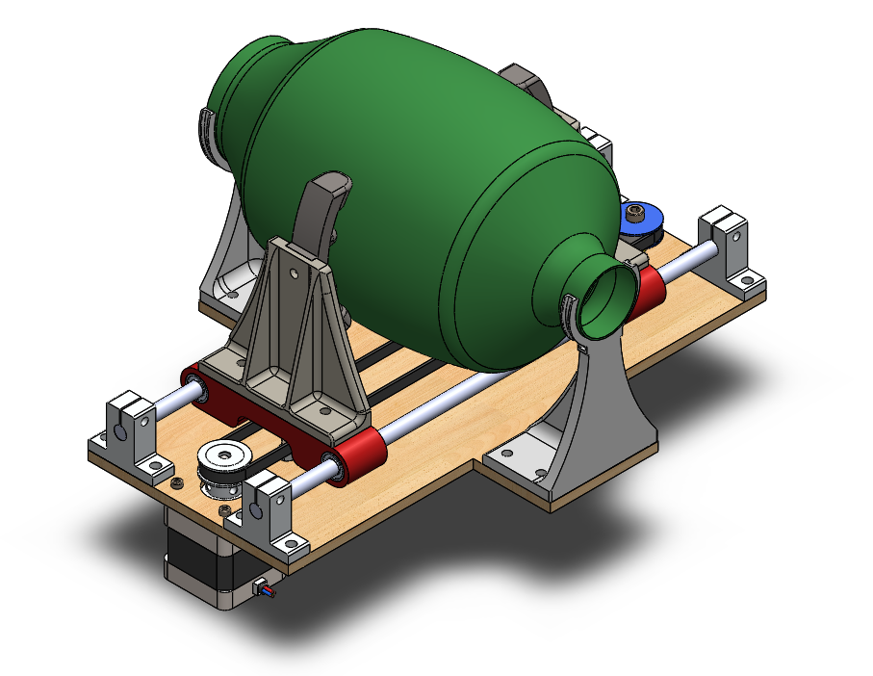

Fig. 1 - Isometric view of the device. It is made up of a 6 mm thick laser cut mdf base.

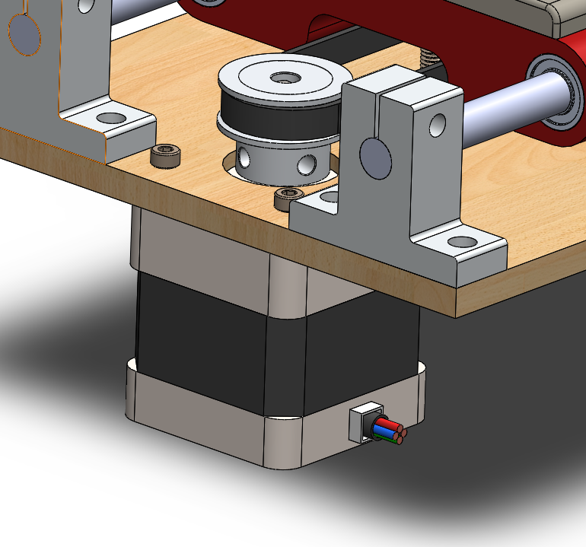

Fig. 2 - The device is powered by a high torque nema 17 motor. I have no evidence of strength yet.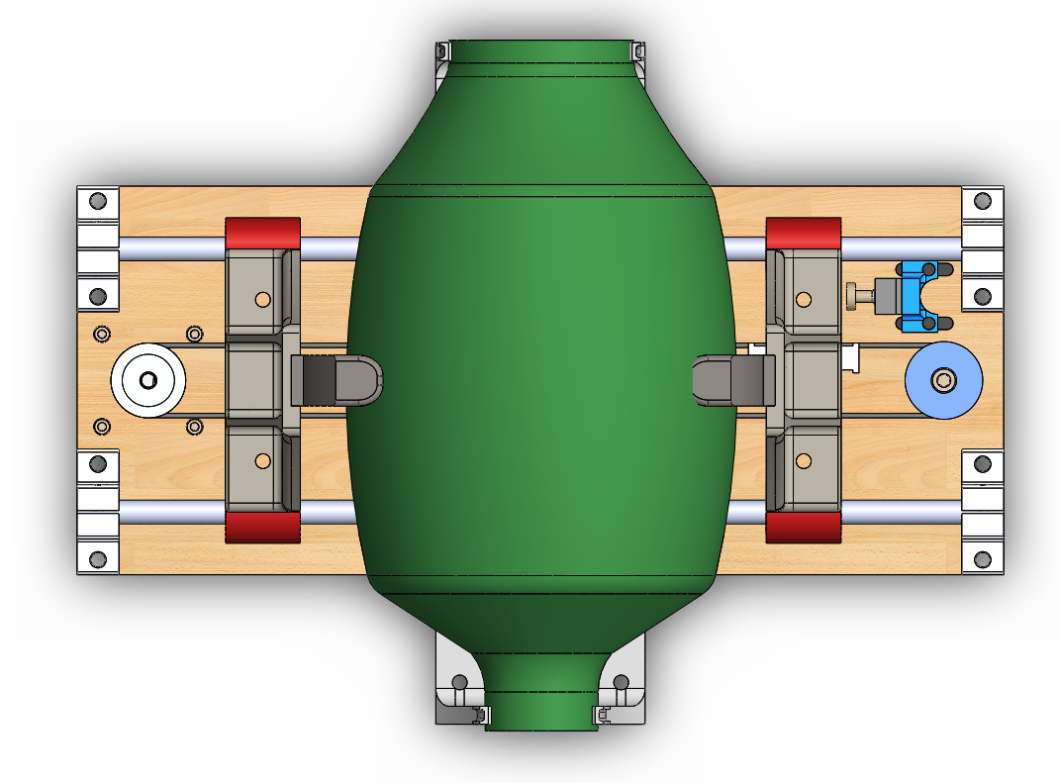

Fig. 3 - The idea is that the pressure claws move by compressing and decompressing the bag according to the set parameters.

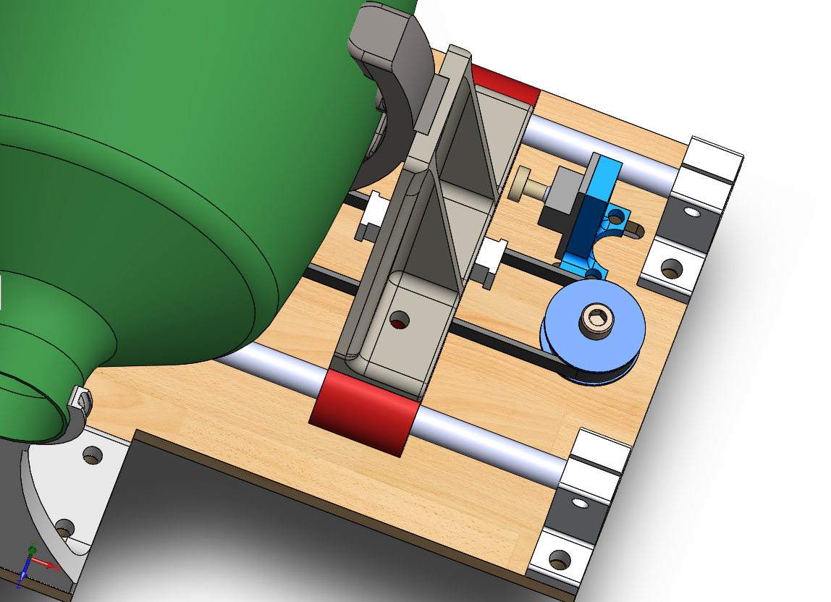

Fig. 4 - The trolleys where the pressure claws are housed are fixed crossed on the gt2 belt to achieve the desired movement. It has a limit switch to inform the starting position before starting.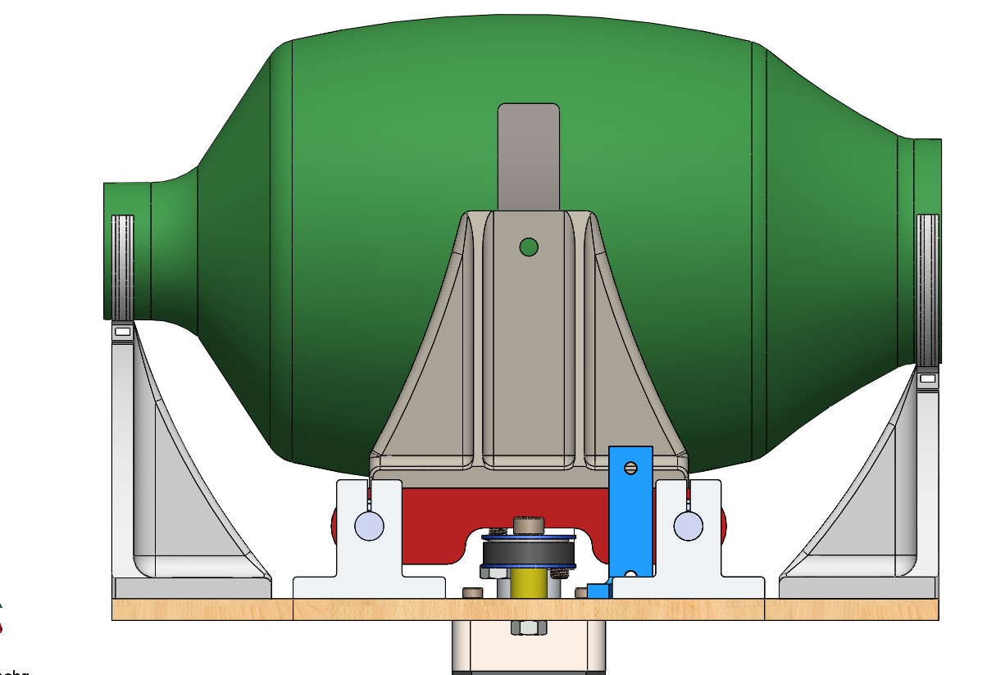

Fig. 5 - The ambu is fixed to the device by means of two supports secured with seals.

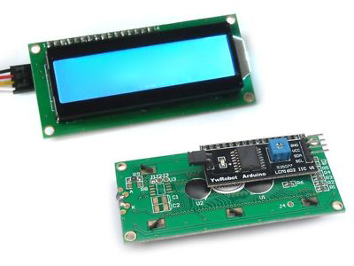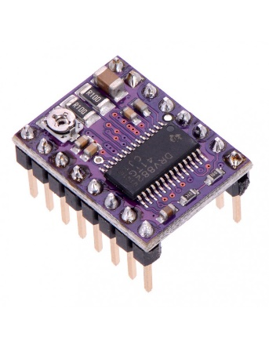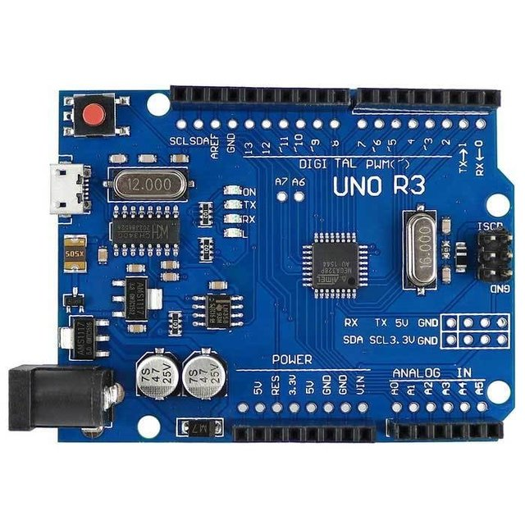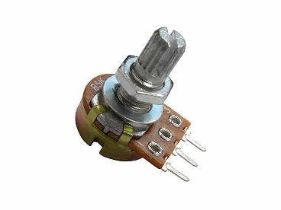

Fig. 5 The hardware to use is: Arduino uno board, lcd ic2, drv 8825 driver, three potentiometers, 12v source or battery.

**Firmware requirements**

Parameters to control:

1) Total volume of air in each breath.

2) Number of breaths per minute.

3) Proportion of time between inhalation and exhalation.

The limit switch I installed in the design is not if necessary.

To carry out the tests, in each parameter to be controlled, the idea is to establish a linear scale from 0 to 10